Assignment 1

# Challenge 1

Let ‘S’ be the statement of A

S: A=> (¬B Ʌ ¬C)

|  |  |  |  |
| --- | --- | --- | --- |
| A | B | C | S |
| 1 | 1 | 1 | 0 |
| 1 | 1 | 0 | 0 |
| 1 | 0 | 1 | 0 |
| 1 | 0 | 0 | 1 |
| 0 | 1 | 1 | 0 |
| 0 | 1 | 0 | 0 |
| 0 | 0 | 1 | 0 |
| 0 | 0 | 0 | 0 |

There is only one possibility that can be deduced from A’s statement, which is ‘A is a knight and B and C are both knaves’. No enough information is provided to deduce what B and C are when ‘A is a knave’.

# Challenge 2

## Question 1

¬­­­ϕ ≡ ¬ (((P => S) Ʌ (Q => R) Ʌ (R => P)) => S)

≡ ¬ (¬ ((¬P V S) Ʌ (¬Q V R) Ʌ (¬R V P)) V S)

≡ ¬¬ ((¬P V S) Ʌ (¬Q V R) Ʌ (¬R V P)) Ʌ ¬S)

≡ (¬P V S) Ʌ (¬Q V R) Ʌ (¬R V P) Ʌ ¬S

## Question 2

Let P, S, Q and R be 0, the negation formula is now (1 V 0) Ʌ (1 V 0) Ʌ (1 V 0) Ʌ 1, which equals true. Therefore, the negation formula is satisfiable and the original formula is non-valid.

## Question 3

Negation ≡ ¬ ((((P V Q) => S) Ʌ (¬P => (R => Q) Ʌ (R V S)) => S)

≡ ¬ (¬ ((¬ (P V Q) V S) Ʌ (¬¬P V (¬R V Q)) Ʌ (R V S)) V S)

≡¬¬ ((¬ (P V Q) V S) Ʌ (¬¬P V (¬R V Q)) Ʌ (R V S)) Ʌ ¬S

≡ (((¬P Ʌ ¬Q) V S) Ʌ (P V (¬R V Q)) Ʌ (R V S)) Ʌ ¬S

≡ ((¬P Ʌ ¬Q) V S) Ʌ (P V ¬R V Q) Ʌ (R V S) Ʌ ¬S

≡ (¬P V S) Ʌ (¬Q V S) Ʌ (P V ¬R V Q) Ʌ (R V S) Ʌ ¬S

## Question 4

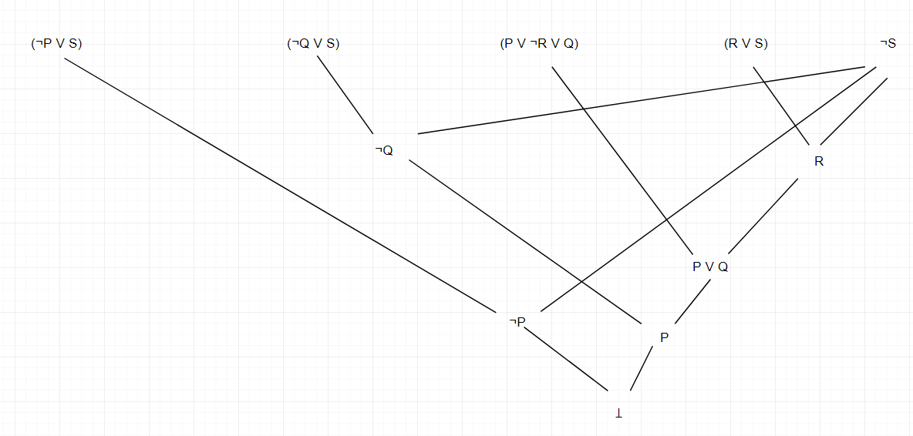

ꓕ can be deriving as the graph shown above, therefore the negation formula is unsatisfiable and the original formula is valid.

# Challenge 3

[Ɐx Ɐy (P(x, y) => P(h(x), h(h(y))))] => Ɐx (P(x, h(x)) Ʌ P(h(h(x)), x))

## Satisfiable

Let h(x) = x * x, P(x, y) means x = y, D = {0}

Therefore, we can get

[P(0, 0) => P(0, 0)] => (P(0, 0) Ʌ P(0, 0))

Which can be transform to true and false form

(true => true) => (true Ʌ true)

true => true

This is always true if the formula follows this interpretation, hence the formula is satisfiable because there is an interpretation showing true.

## Non-valid

Let h(x) = x * x, P(x, y) means x < y, D = {2}

We can get from the formula

[P(2, 2) => P(4, 16)] => (P(2, 4) Ʌ P(16, 2))

Then the true and false form is

(false => true) => (true Ʌ false)

true => false

This is always false if the formula follows this interpretation, hence the formula is not valid because there is an interpretation showing false.

# Challenge 4

## Question 1

Ɐx Ɐy ((S(x) Ʌ ¬P(y, x)) => H(x))

## Question 2

Ɐx (S(x) => ((Ɐy (P(y, x) => R(y))) => H(x)))

## Question 3

Ɐx (S(x) => ((Ɐy (P(y, x) => R(y))) => H(x)))

Eliminate =>

Ɐx (¬S(x) V (¬ (Ɐy (¬P(y, x) V R(y))) V H(x)))

Eliminate negation

Ɐx (¬S(x) V (ⱻy (P(y, x) Ʌ ¬R(y))) V H(x)))

Eliminate existential quantifiers

Ɐx (¬S(x) V ((P(f(x), x) Ʌ ¬R(f(x)))) V H(x)))

Drop Universal Quantifiers

(¬S(x) V ((P(f(x), x) Ʌ ¬R(f(x)))) V H(x)))

Turn to CNF

(¬S(x) V ((P(f(x), x) V H(x)) Ʌ (¬R(f(x)) V H(x)))

(¬S(x) V P(f(x), x) V H(x)) Ʌ (¬S(x) V ¬R(f(x)) V H(x))

Clausal form

{{¬S(x), P(f(x), x), H(x))}, {¬S(x), ¬R(f(x)), H(x)}}

## Question 4

¬(Ɐx Ɐy ((S(x) Ʌ ¬P(y, x)) => H(x)))

Eliminate =>

¬(Ɐx Ɐy (¬ (S(x) Ʌ ¬P(y, x)) V H(x)))

Eliminate negation

ⱻx ⱻy ¬ (¬ (S(x) Ʌ ¬P(y, x)) V H(x)))

ⱻx ⱻy (¬¬ (S(x) Ʌ ¬P(y, x)) Ʌ ¬H(x)))

ⱻx ⱻy ((S(x) Ʌ ¬P(y, x)) Ʌ ¬H(x)))

Eliminate existential quantifiers

(S(a) Ʌ ¬P(b, a) Ʌ ¬H(a)))

Clausal form

{{S(a)}, {¬P(b, a)}, {¬H(a)}}

## Question 5

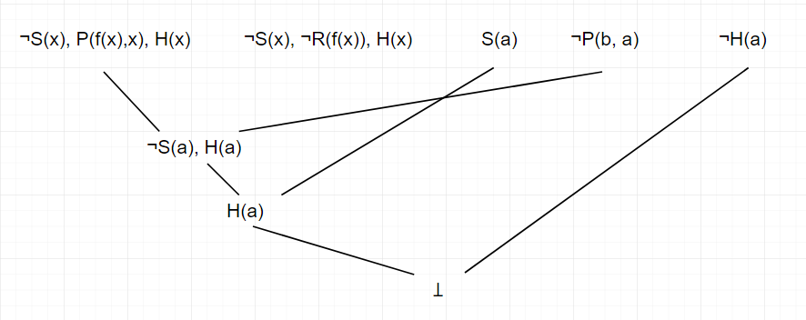

ꓕ is deriving from S2 Ʌ ¬S1. Therefore, we can say that S1 follows from S2.